UNICEF P3 Technical Assessment

Data Perspective on the Evolution of Educational Performance in 4- to 5-Year-Old Children in Zimbabwe

# Introduction

The early childhood years, particularly between the ages of 4 and 5, are crucial for cognitive, physical, and socio-emotional development. Drawing on data from the 2019 Zimbabwe Multiple Indicator Cluster Survey (MICS6), which surveyed over 11,000 households, the report analyzes the progression of key educational indicators—literacy, numeracy, physical skills, learning capabilities, and socio-emotional development—across different age months.

# Methodology

The analysis is based on a dataset containing coded responses for various skill indicators across different child age months. The mean proportion of children demonstrating specific skills for each month was calculated. Binary outcomes (1 = Yes, 0 = No) were used to facilitate analysis, and trends were visualized using fractional polynomial fitted plots with confidence intervals to illustrate variability.

# Results and Discussion

## Literacy and Math Skills Evolution

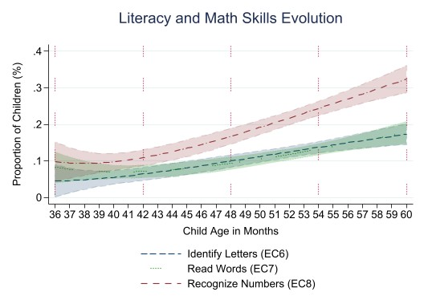The analysis reveals a steady increase in the proportion of children identifying letters, reading words, and recognizing numbers as they age. The most significant growth occurs between 48 and 60 months, aligning with the transition into formal schooling. This period is marked by rapid development in these foundational skills.

**Identify Letters (EC6)**: The proportion of children identifying letters is low at 2.2% at 36 months but increases significantly to 15.5% by 54 months. **Read Words (EC7)**: Reading skills gradually increase, reaching 17.9% by 60 months, indicating that while progress is made, many children still struggle with this skill at the end of the observed period. **Recognize Numbers (EC8)**: Recognition of numbers shows a steady increase, peaking at 30.4% by 56 months, suggesting that children are developing numerical literacy as they approach school age.

## Physical Skills Evolution

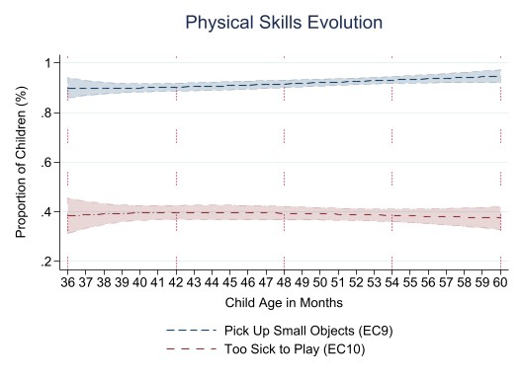The ability to pick up small objects—a fine motor skill—shows high proficiency from around 36 months, continuing to develop steadily. The proportion of children reported as being too sick to play decreases slightly with age, indicating improved health and physical resilience as children grow.

**Pick Up Small Objects (EC9):** The ability to pick up small objects remains high throughout the observed months, with over 90% of children demonstrating this skill by 36 months. **Too Sick to Play (EC10):** The percentage of children reported as too sick to play shows fluctuations, with a slight decrease in reported sickness as children age, indicating improved health and resilience.

## Learning Skills Evolution

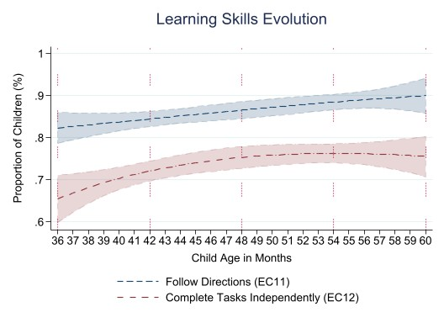The data indicate a marked improvement in these areas as children age, particularly between 48 and 60 months, suggesting increased readiness for structured learning environments by age 5.

**Follow Directions (EC11)**: The ability to follow simple directions increases significantly, reaching approximately 87.5% by 60 months, highlighting the development of cognitive skills. **Complete Tasks Independently (EC12)**: Independence in task completion also rises, with about 73.2% of children demonstrating this ability by 60 months, indicating growing self-sufficiency.

## Socio-emotional Development Evolution

Socio-emotional skills, including getting along with others, controlling aggressive behavior, and maintaining attention, are vital for a child's well-being and success in group settings. The data show consistent improvement in social interactions, with a notable decrease in aggressive behavior as children age. However, challenges remain in maintaining attention, which improves gradually but remains an area requiring attention in early education programs.

**Gets Along with Others (EC13)**: The proportion of children who get along well with others is consistently high, peaking at 97.6% by 60 months, suggesting positive social interactions. **Aggressive Behaviors (EC14)**: Reports of aggressive behaviors show a decline as children age, with only 39.1% exhibiting these behaviors by 60 months, indicating improved socialization. **Easily Distracted (EC15)**: The percentage of children reported as easily distracted remains relatively stable, suggesting that attention spans may vary among children.

# Conclusion

The analysis of educational performance among 4- to 5-year-old children in Zimbabwe reveals significant growth in literacy, numeracy, physical, learning, and socio-emotional skills as they approach school age. The period between 48 and 60 months is particularly critical, with rapid development indicating readiness for formal education. These findings underscore the importance of targeted interventions during this time to ensure that children acquire the necessary skills for academic and social success.